|  |  |  |  |  |  |
| --- | --- | --- | --- | --- | --- |
| Date | 6-Dec-22 | | | Tester Name | Mohammad Yusuf |
| Environment | Penfax - Test | | | Login used |  |
| Operating System | Select OS | Version: | Update: | | |
| Software Used | Select Software | Version: | Update: | | |
| Select Software | Version: | Update: | | |
| Release version |  | | | | |
| Title | M17 Contributions & DCT | | | | |
| Test Type | Regression | | | | |
| Test Scenario | M17.17 Running Employer Contribution Detail for Employers | | | | |
|  |  | | | | |
| Expected Results | Report should be available as per queried data and should be opened in both PDF and CSV format. | | | | |
| Pass/Fail | Pass | | | JIRA# | N/A |

Describe your steps with screenshots:

1. Log into MEPP DCT and select the Employer from the dropdown.

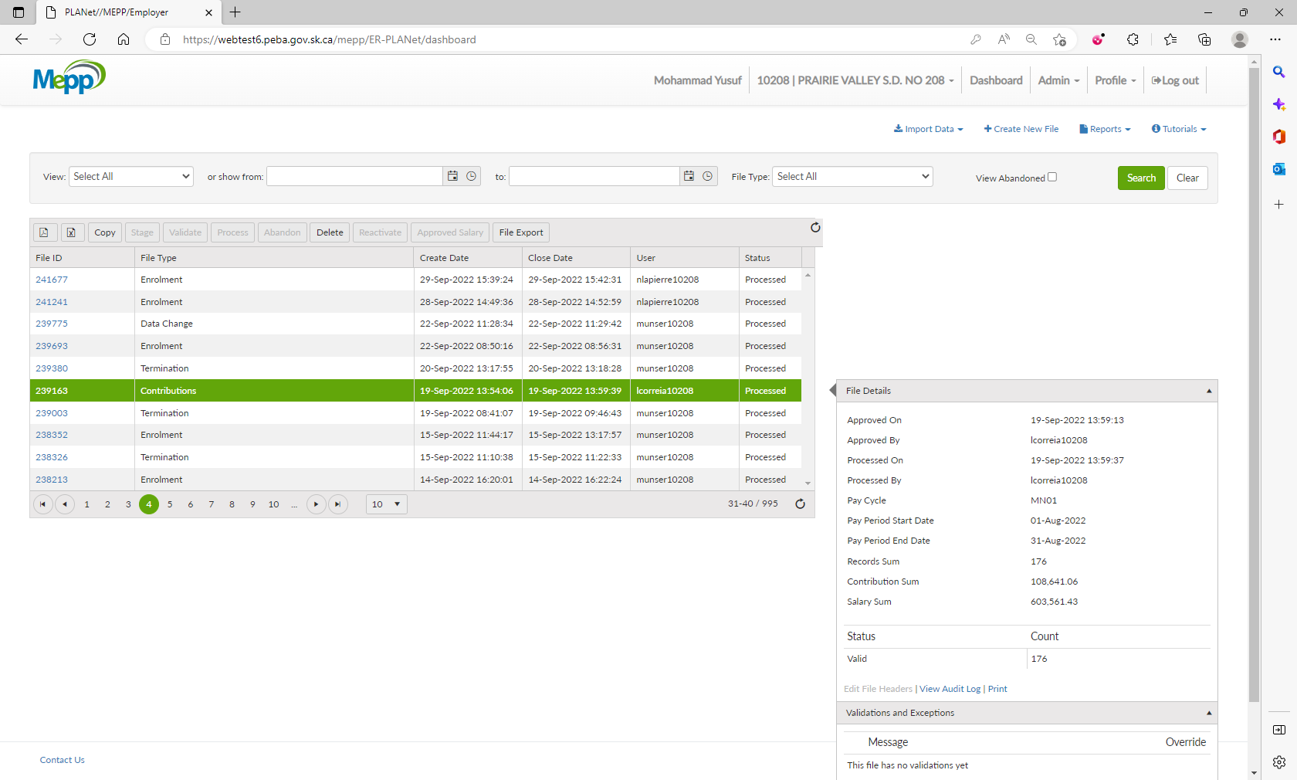

1. Select any of the processed contribution files.

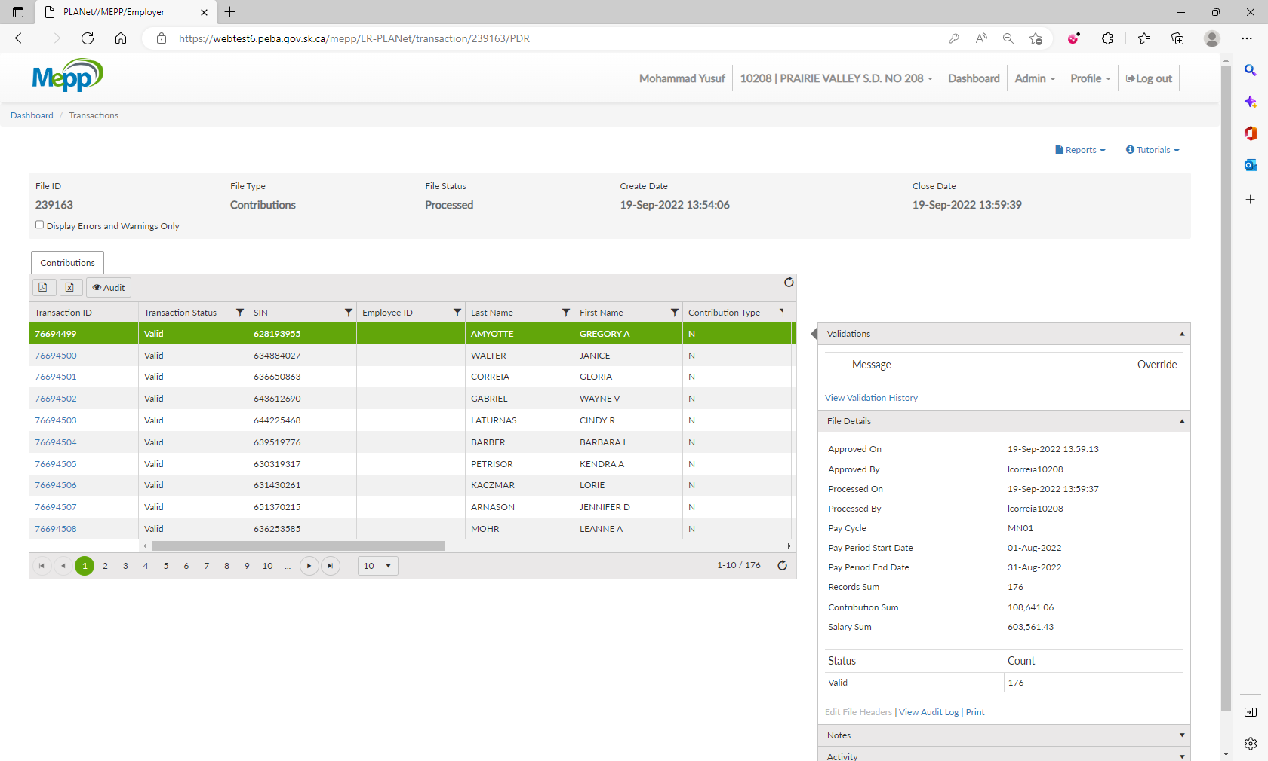

1. Click on Reports and select Employer Contribution Detail.

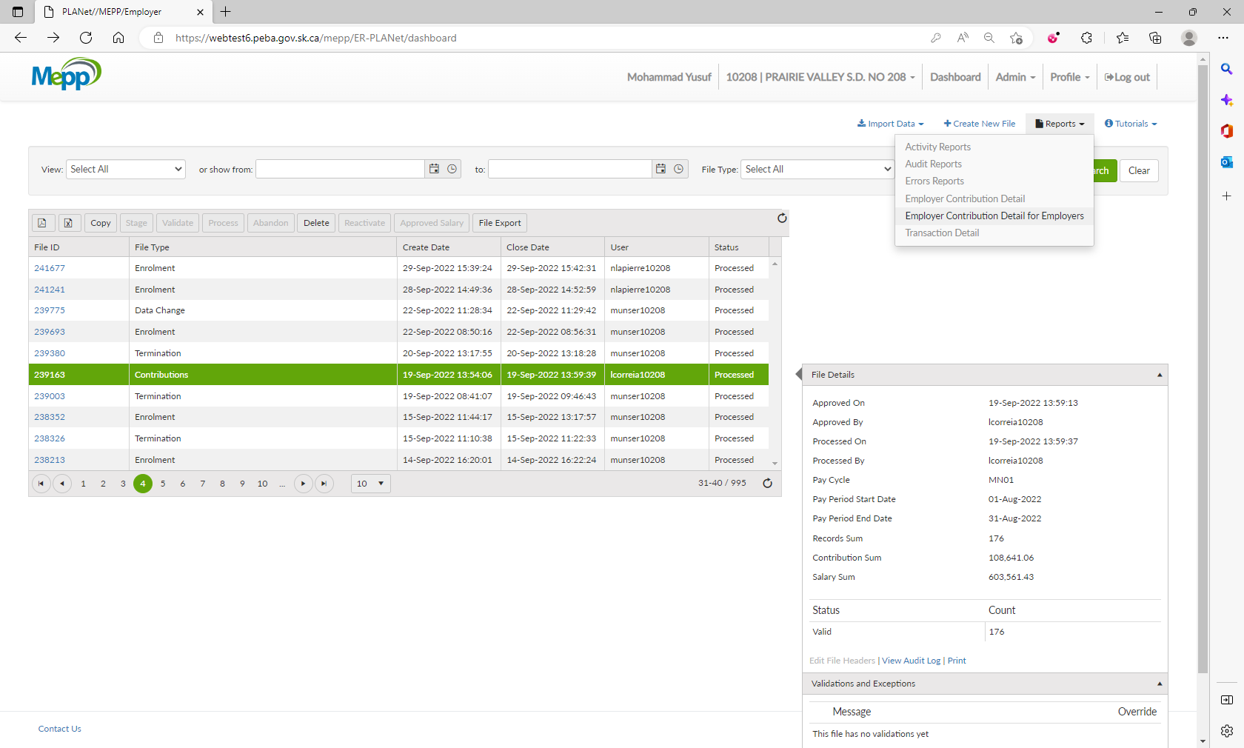

1. Input your criteria and submit.

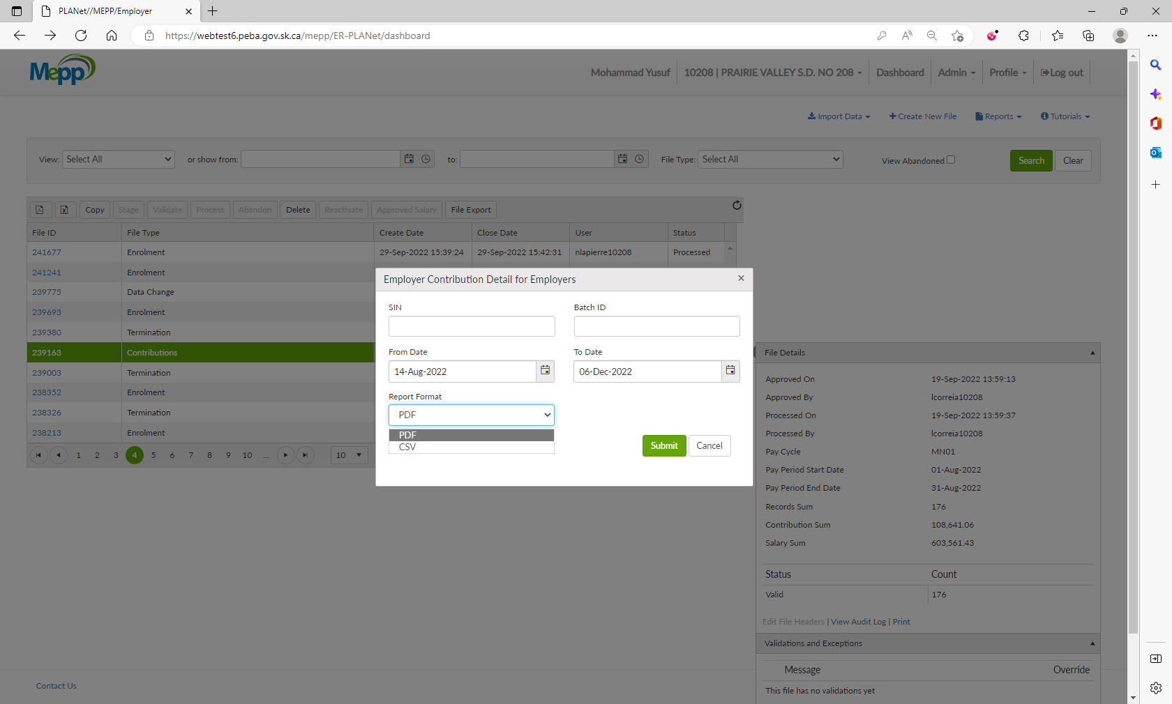

1. It will open a report in PDF format.

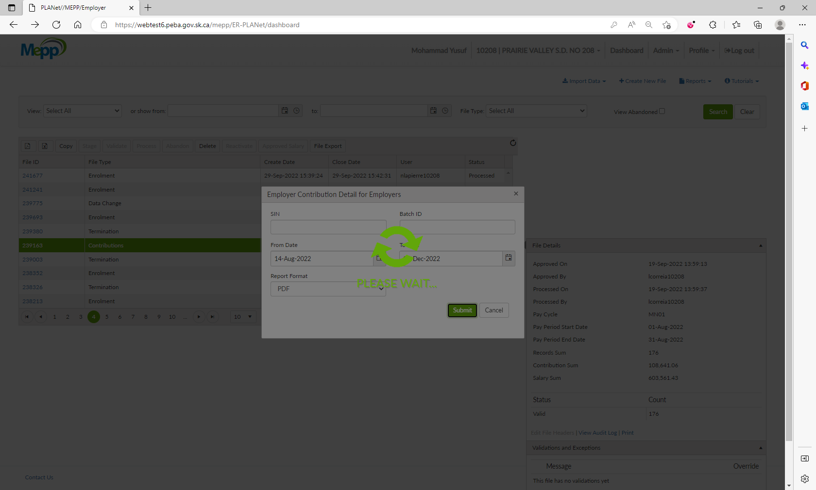

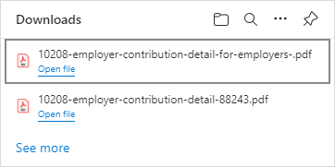

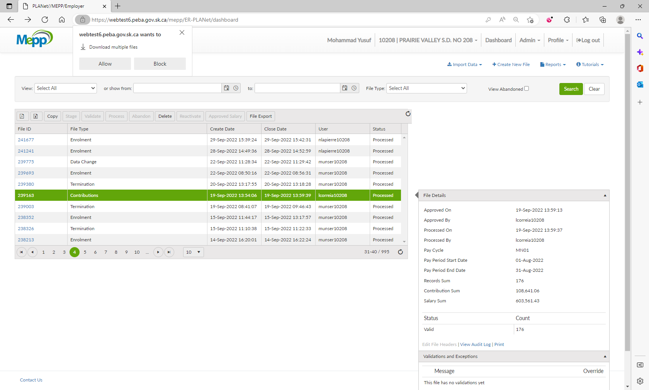

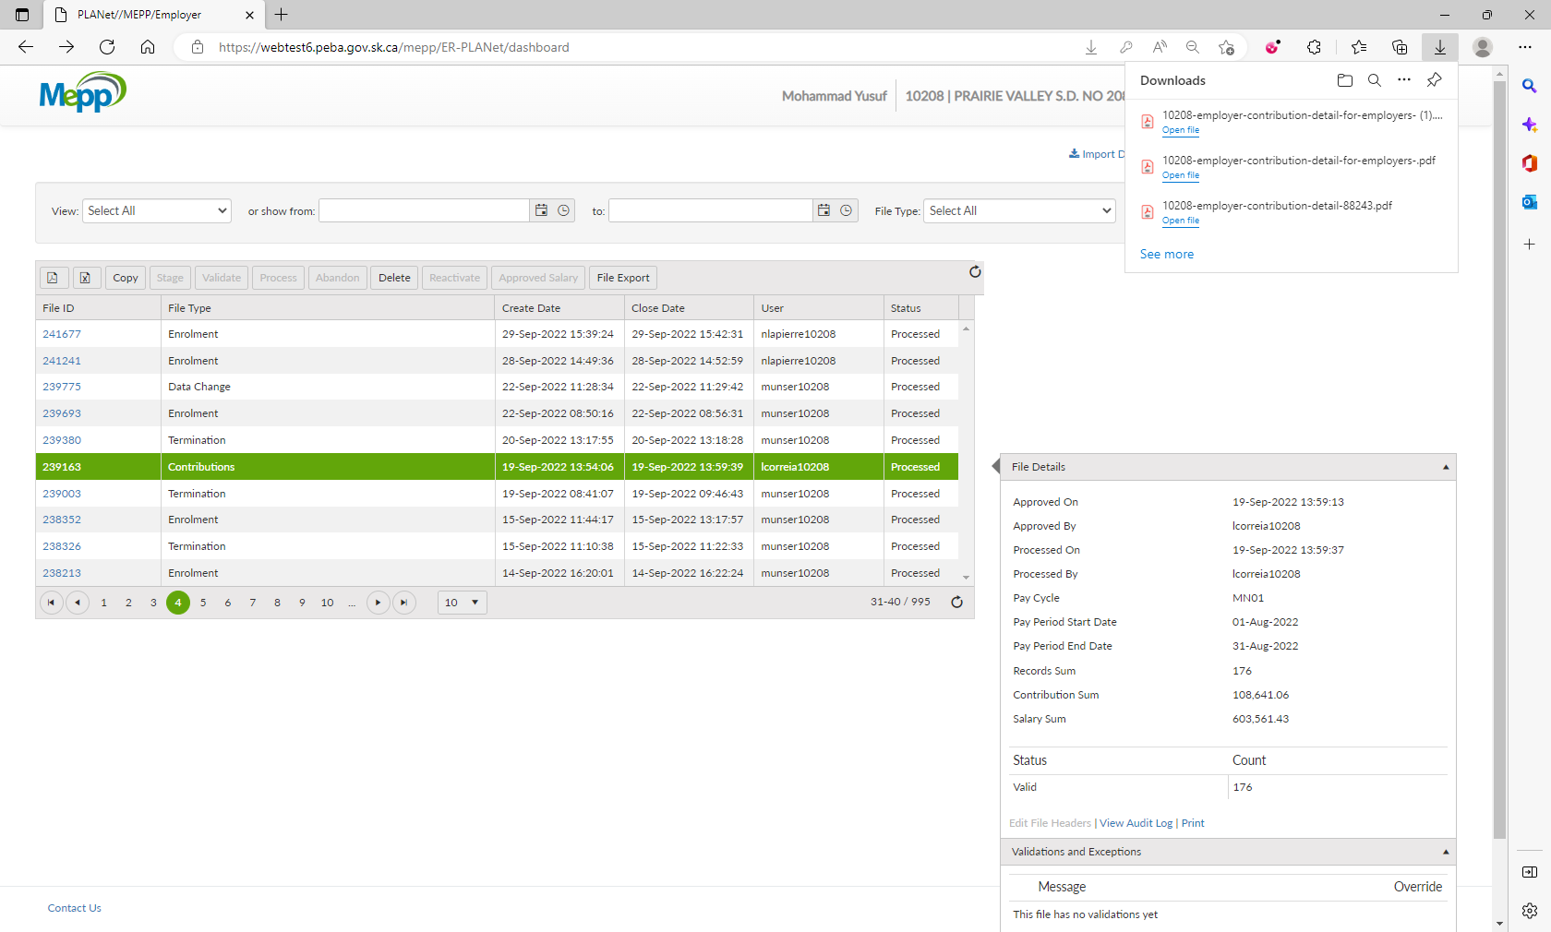

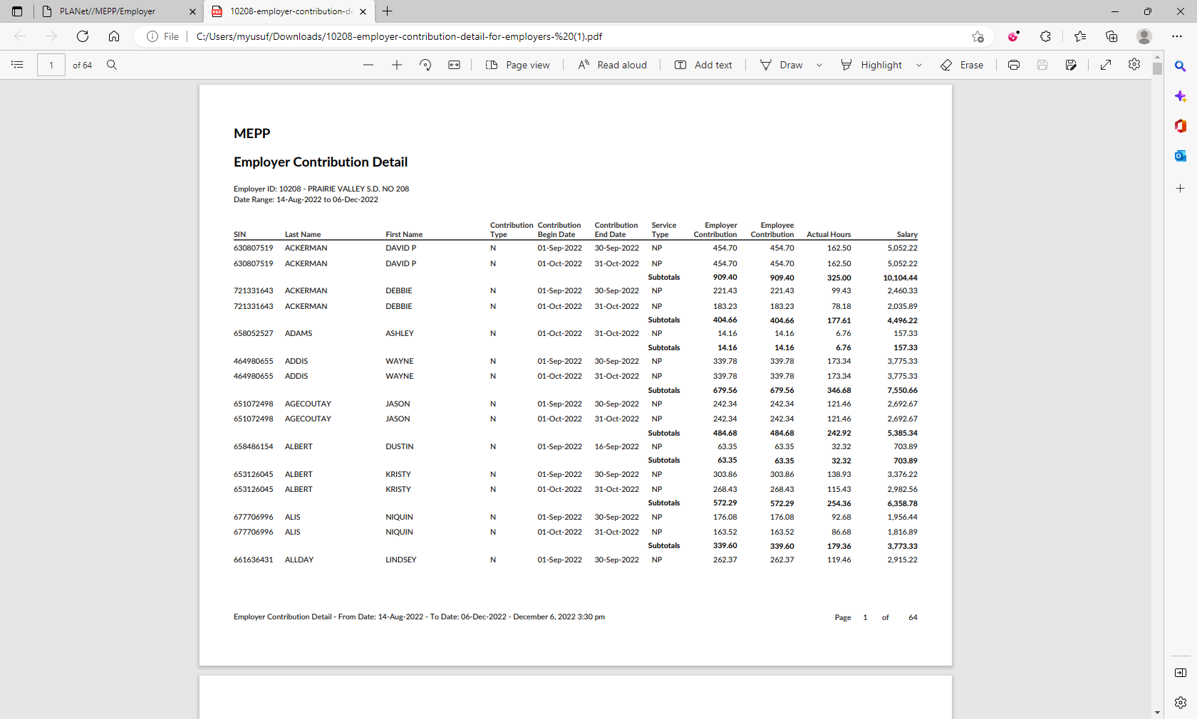

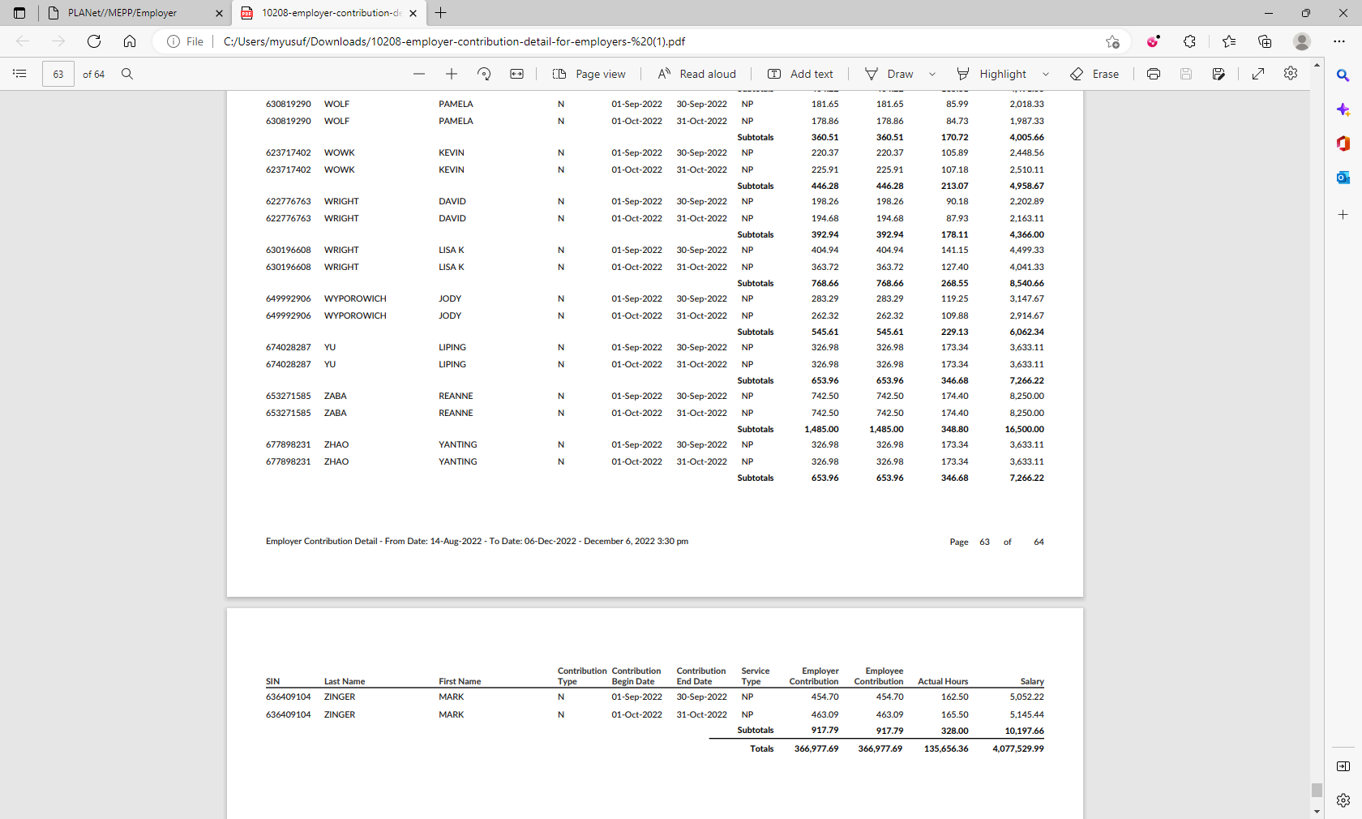

1. Change the Report Format to CSV and submit.

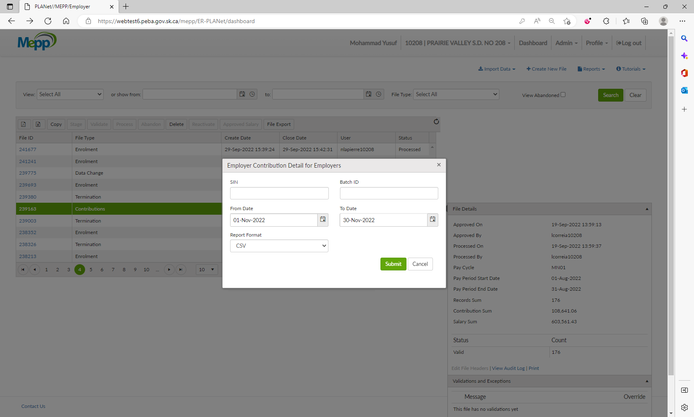

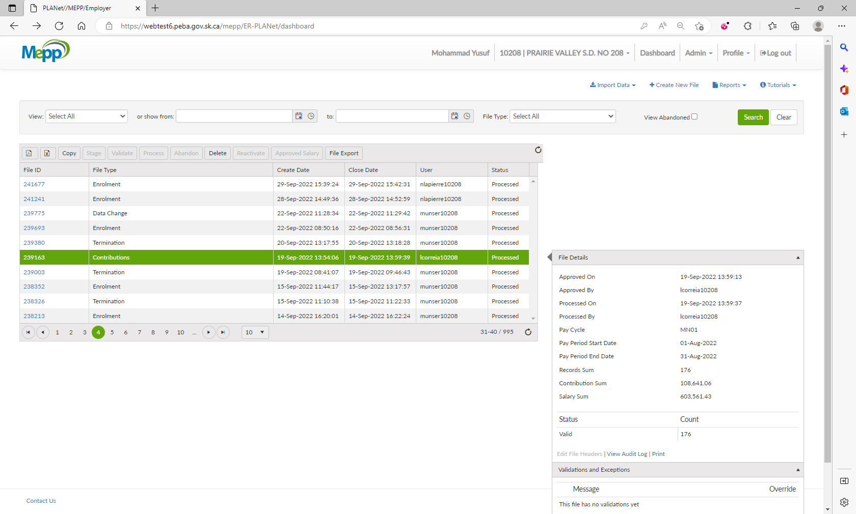

1. It will open a report in CSV (Excel) format.

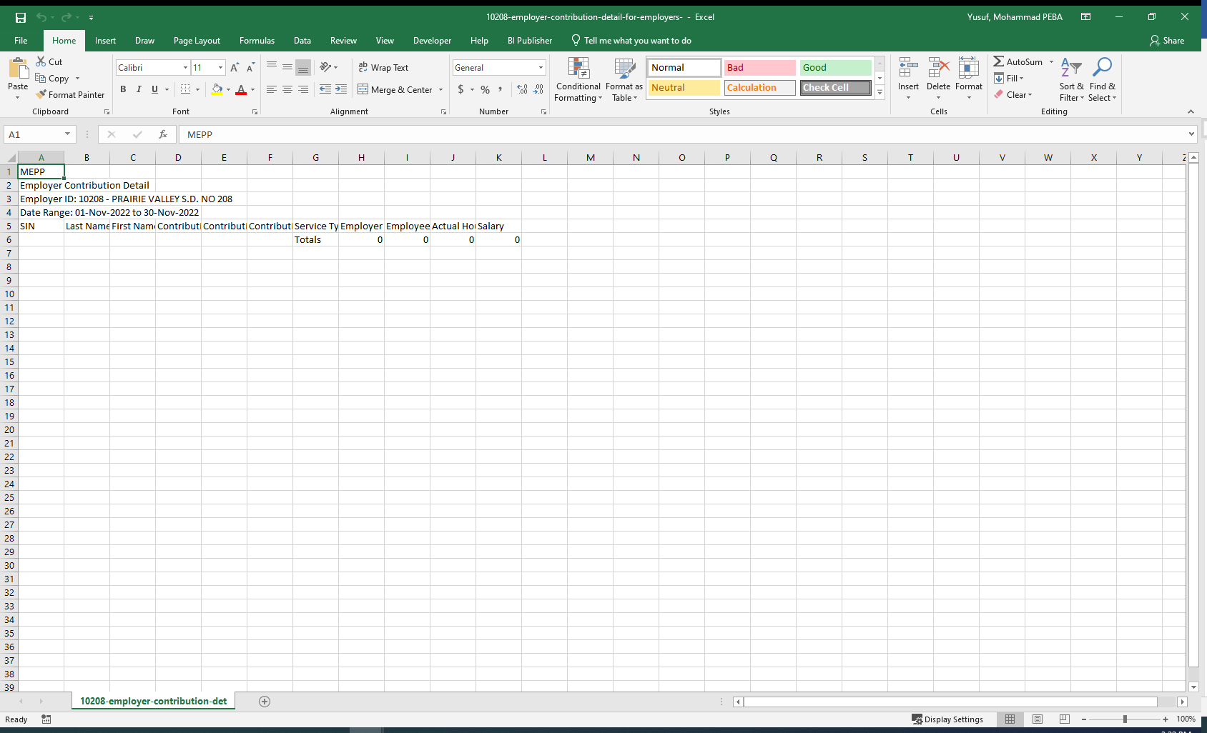

For the month of October

